|  |  |
| --- | --- |
| **Operating Systems & Networking Fundamentals**  Diploma in CSF/IT  Year 1 (2021/22) Semester 2 | Week 5 |
| 2 hours |
| Demand Paging Activity | |

**Objectives**

1. To understand the differences between page and frame
2. To understand the concept of mapping and referencing of process pages to memory frames
3. To understand the concept of Virtual Memory implemented using demand paging technique

**Introduction:**

DemandPaging.swf is a courseware created to aid students to understand the concept of Virtual Memory, in particular the mapping and referencing of pages as well as swapping pages. The courseware makes use of simulation to create the visualization effect and students are able to customize the environment and view the results.

The courseware allows students to customize the number of processes, process size and memory size and view the simulated results to better understand the Virtual Memory concept.

**Activity 1: Mapping and Referencing Pages**

*(Estimated time: 60 minutes)*

**Steps:**

1. Download DemandPaging.swf from MEL. Double click to start the courseware animation in browser. Alternatively, file open with a browser.

NB: If your browser is not able to play the swf file, please download Ruffle software in MEL and use it to run the swf file.

1. After the Introduction, click **Next** to enter the main page of the courseware.
2. Click on **Mapping and Referencing Pages** to start the simulation.
3. You are now presented with the options that allow you to customize the number of processes and size of each process. Try the following:
   1. **Process A = 4 MB**, **Process B = 4 MB** *(click Next)*
   2. **Memory Size = 32 MB** *(click Next)*

*(at any time if you need to change the settings, you may click Back)*

1. The simulation is about to start now based on your customization. You should see 2 processes (A and B) created as shown in the next page:

**Page File in Hard disk**

**RAM**

**Page Table**

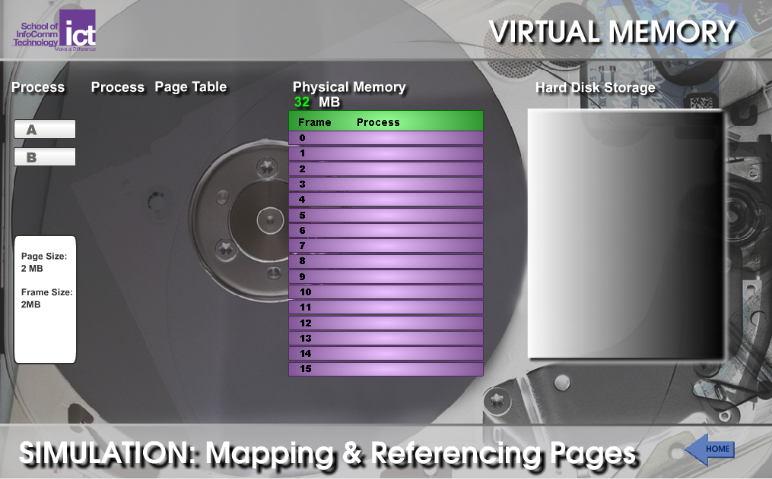

1. The tool pre-set the Page size and Frame size to 2 MB as shown in the screen.

Q1: Can Page size and Frame size be different? Why? What is the typical size of page and frame size?

No, they cannot be different. Because the frame is stores the page and if they are not the same size, it is not possible. The typical size of page and frame size is 4 KB.

1. Now, click on Process A (to simulate user starting a new process) on the left of the screen. Record your observation.

A page fault occurs because the process is not in physical memory yet.

Content of the selected process will be swapped into physical memory from the hard disk.

The status in the process page table updates to “valid” from “invalid” when the process pages are swapped into memory

Frames 0-1 are used as process A is only 4 MB and each frame is 2 MB. Status only becomes “valid” when the process has been loaded into the main memory.

All processes are located in the page file of hard disk at start. Through demand paging, these processes will be “swapped in” into main memory when they are needed.

Each process is divided into fixed size pages. In this case Process A (4 MB) is divided into 2 pages of 2 MB each.

Process A Page Table shows the mapping of Page 0 and 1 to Frame 0 and 1 in RAM. Status of both entries is set to Valid when pages are swapped in.

1. Now click on Process B and see that Process B is swapped into RAM as shown below.

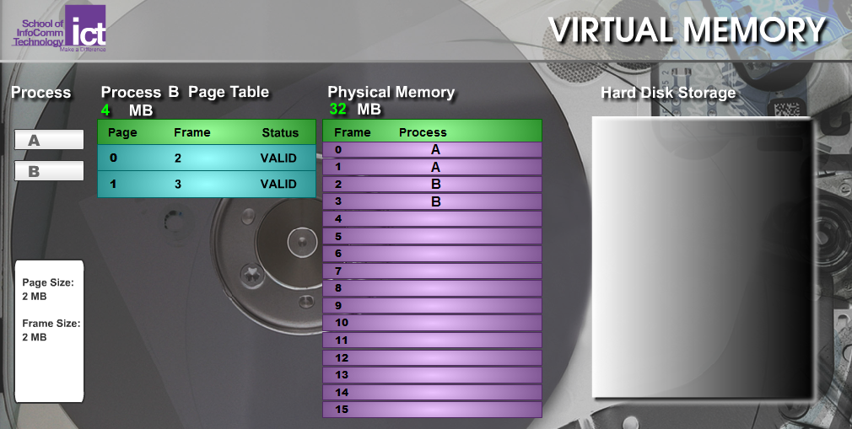

Process B Page Table shows the mapping of Page 0 and 1 to Frame 2 and 3 in RAM. Status of both entries is set to Valid when pages are swapped in.

1. Experiment with other settings such as different number of processes, process size and RAM size to see the differences in the simulation results. Record your observations below.

The order when opening the processes matter. If D is clicked before A, process D will be loaded into the main memory before process A. The smaller the process, the fewer frames it needs. The larger your RAM (physical memory), the more frames there will be.

**Activity 2: Swapping Pages**

*(Estimated time: 60 minutes)*

**Steps:**

1. Click **Home** to return to the main page of the courseware.
2. Click **Swapping Pages** to start the next activity.
3. Try the following:
   1. **Process A = 20 MB**, **Process B = 20 MB**, **Process C = 4 MB** *(click Next)*
   2. **Memory Size = 32 MB** *(click Next)*
4. Click on Process A now. What are your observations?

Frames 0-9 are used up by process A and the status becomes “valid” when process A goes from the hard disk storage to the physical memory (main memory).

1. Click on Process B. What are your observations?

As there isn’t enough space in the RAM, Frames 0-3 which contained process A were swapped out to accommodate process B being loaded into the memory. Process B took frames from 0-3 and from 10-15. The inactive frames of process A were swapped from the main memory to the hard disk storage.

Process B Page Table is shown below:

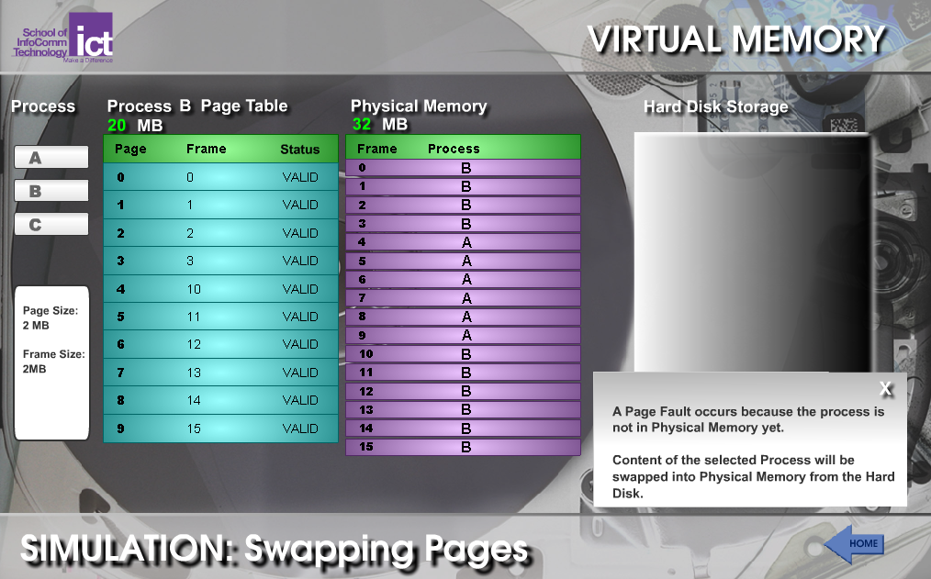

1. Now click on Process C. What are your observations?

Frames from 0-1 changed from process B to process C. Because there wasn’t enough RAM storage to accommodate process C, it swapped the inactive process B in frames 0-1 from the main memory to the hard disk storage so that there is space to accommodate process C.

Process C Page Table is shown below:

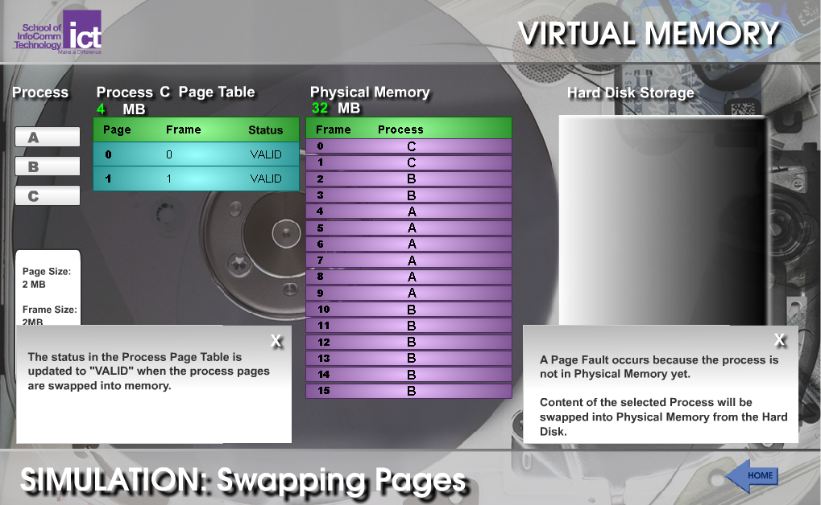

1. Now proceed to try other parameters and record your observations below.

When the RAM is big enough to accommodate all the processes, no swapping of inactive process from RAM to hard disk storage is necessary as there are sufficient frames to run and store all the processes. Only when the RAM is insufficient, does page fault occur and the inactive processes must be swapped from the main memory to the hard disk to accommodate frames for the new process.

- End -